

Cloud Computing Lab 10

Submitted To:
Sir Shoaib & Sir Waqas

Submitted By:
Hamail Fatima

Roll No:
2023-BSE-023

Section:
5(A)

Task 1 — GitHub CLI Codespace Setup & Authentication
Goal: Install GH CLI (if not present), authenticate for Codespace use, and connect into the Codespace shell (all steps inside Codespace unless noted).
- Install GitHub CLI:
winget install --id GitHub.cli
  - Save screenshot as: task1_gh_install.png — terminal showing the winget install command output.
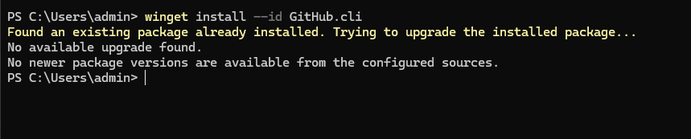
- Authenticate GH CLI for Codespaces:
gh auth login -s codespace
  - When prompted, generate a GitHub access token (classic). Set scopes to: admin:org, codespace, repo.
  - Save screenshot as: task1_gh_auth_login.png — screenshot of gh auth login confirmation (redact token).
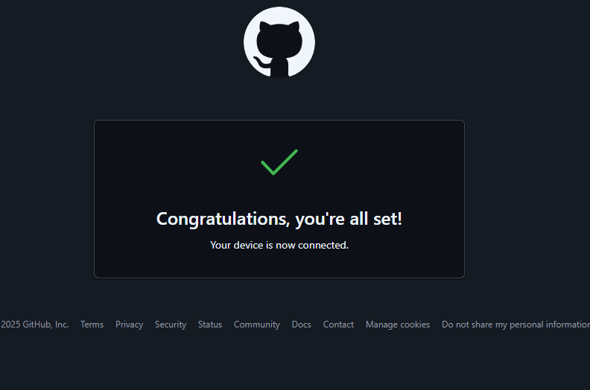
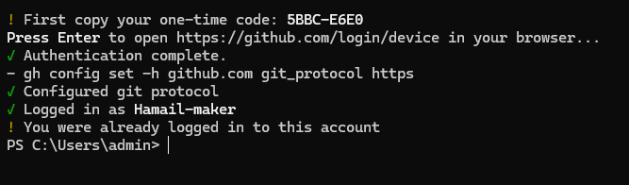
- List available codespaces:
gh codespace list
  - Save screenshot as: task1_codespace_list.png — output showing the codespace name.
- Connect to a codespace via SSH:
gh codespace ssh -c <name_of_codespace>
  - Save screenshot as: task1_codespace_ssh_connected.png — terminal inside the Codespace shell after ssh.
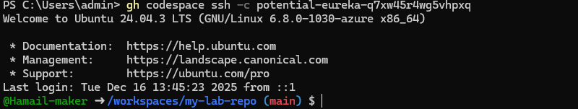
Task 2 — Install AWS CLI, Terraform CLI, Provider Setup
Goal: Install AWS CLI (if not present) & Terraform CLI inside Codespace; configure initial Terraform provider.
A. Install AWS CLI (Skip if already installed)
- In Codespace shell, install AWS CLI:
- curl "https://awscli.amazonaws.com/awscli-exe-linux-x86_64.zip" -o "awscliv2.zip"
- unzip awscliv2.zip
- sudo ./aws/install
aws --version
  - Save screenshot as: task2_aws_install_and_version.png — show AWS CLI installation and version output.
- Configure AWS CLI:
aws configure
  - Save screenshot as: task2_aws_configure_and_files.png — show aws configure prompt (redact secret values).
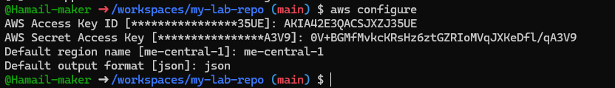
  - Then check config files:
cat ~/.aws/credentials
cat ~/.aws/config
  - Save screenshot as: task2_aws_configure_and_files.png — output of cat commands (redact secret keys if visible).
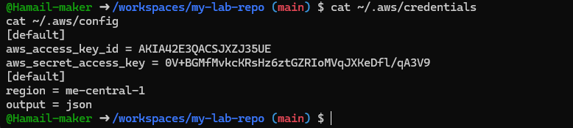
- Verify AWS CLI connectivity:
aws sts get-caller-identity
  - Save screenshot as: task2_aws_get_caller_identity.png — output of aws sts get-caller-identity.
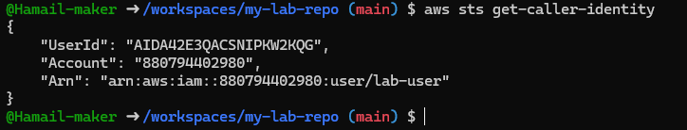

B. Install Terraform CLI
- Install Terraform CLI:
- wget -O - https://apt.releases.hashicorp.com/gpg | sudo gpg --dearmor -o /usr/share/keyrings/hashicorp-archive-keyring.gpg
- echo "deb [arch=$(dpkg --print-architecture) signed-by=/usr/share/keyrings/hashicorp-archive-keyring.gpg] https://apt.releases.hashicorp.com $(grep -oP '(?<=UBUNTU_CODENAME=).*' /etc/os-release || lsb_release -cs) main" | sudo tee /etc/apt/sources.list.d/hashicorp.list
- sudo apt update
- sudo apt install terraform
- which terraform
terraform --version
  - Save screenshot as: task2_terraform_install_and_version.png — terraform installation and version check output.
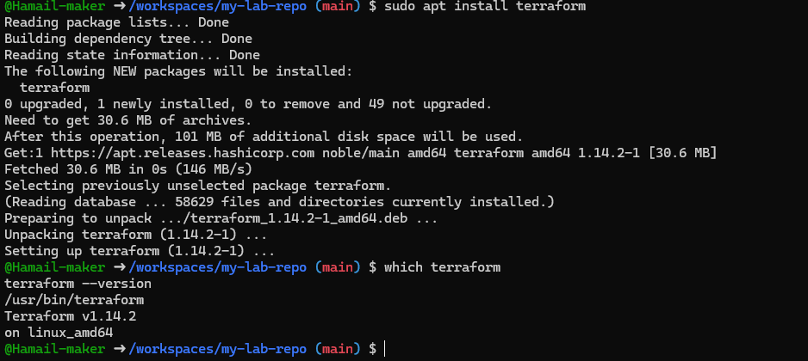
C. Provider Configuration (main.tf)
- Create main.tf using Vim:
vim main.tf
  - Save screenshot as: task2_provider_file_creation.png — creation/editing of main.tf.

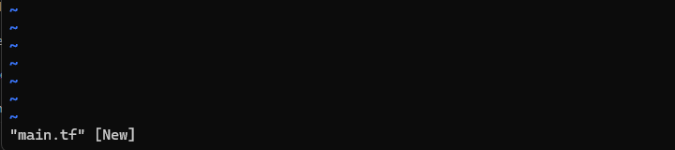
- Inside main.tf, write:
- provider "aws" {
- shared_config_files = ["~/.aws/config"]
- shared_credentials_files = ["~/.aws/credentials"]
}
  - Save screenshot as: task2_provider_block.png — final content saved in main.tf.
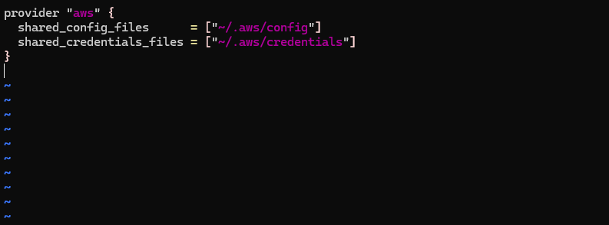
- Save and quit: Press ESC then :wq
  - Save screenshot as: task2_vim_save_main_tf.png — Vim save confirmation (optional).
- Initialize Terraform:
terraform init
  - Save screenshot as: task2_terraform_init_output.png — terraform init output.
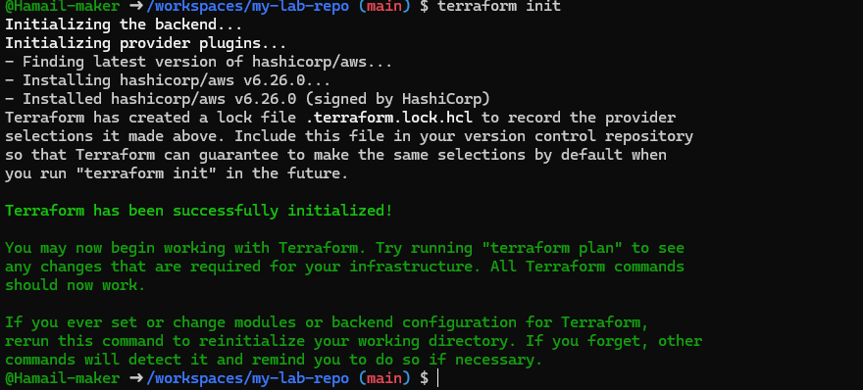
- Show contents of .terraform.lock.hcl:
cat .terraform.lock.hcl
  - Save screenshot as: task2_terraform_lock_hcl.png — output of .terraform.lock.hcl.
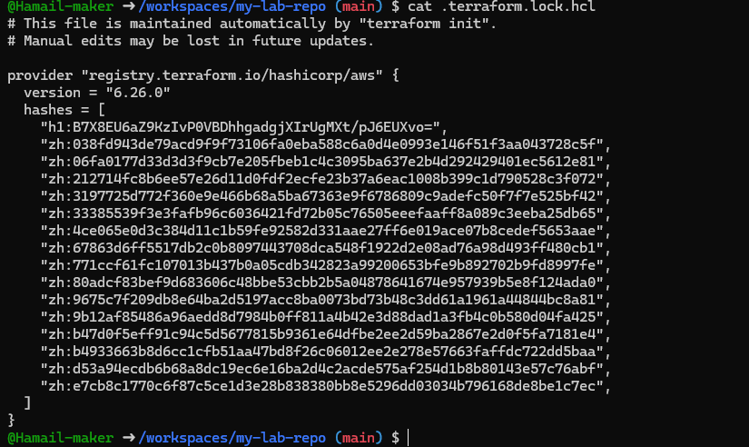
- Show contents of .terraform/ directory:
ls .terraform/
  - Save screenshot as: task2_terraform_dir_ls.png — output of ls .terraform/.
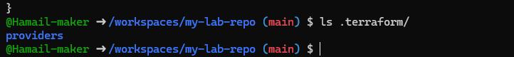
Task 3 — VPC/Subnet Creation, Initialization, Verification
Goal: Use Terraform to create VPC & Subnet resources, verify via CLI.
- Edit main.tf to add:
- resource "aws_vpc" "development_vpc" {
- cidr_block = "10.0.0.0/16"
- }

- resource "aws_subnet" "dev_subnet_1" {
- vpc_id = aws_vpc.development_vpc.id
- cidr_block = "10.0.10.0/24"
- availability_zone = "me-central-1a"
}
  - Use vim main.tf, edit and insert code.
  - Save screenshot as: task3_main_tf_resource_add.png — new resources added and visible in main.tf.
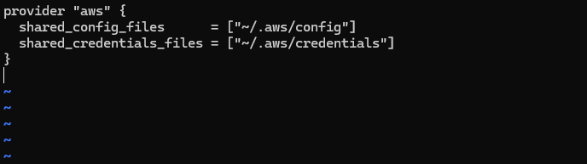
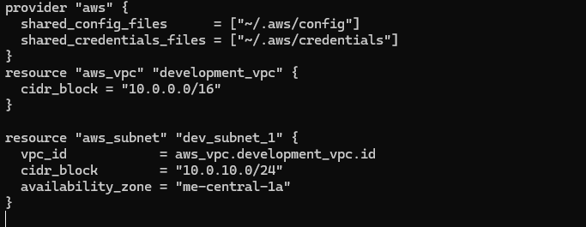
- Run:
terraform apply
  - Type yes when prompted.
  - Save screenshot as: task3_terraform_apply_vpc_subnet.png — output showing successful apply and resources creation.
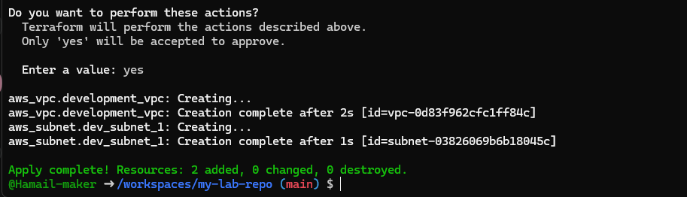
- Verify resources using AWS CLI:
  - Run:
aws ec2 describe-subnets --filter "Name=subnet-id,Values=<subnet-id>"
    - Save screenshot as: task3_aws_cli_verify_subnet.png — output of describe-subnets command.
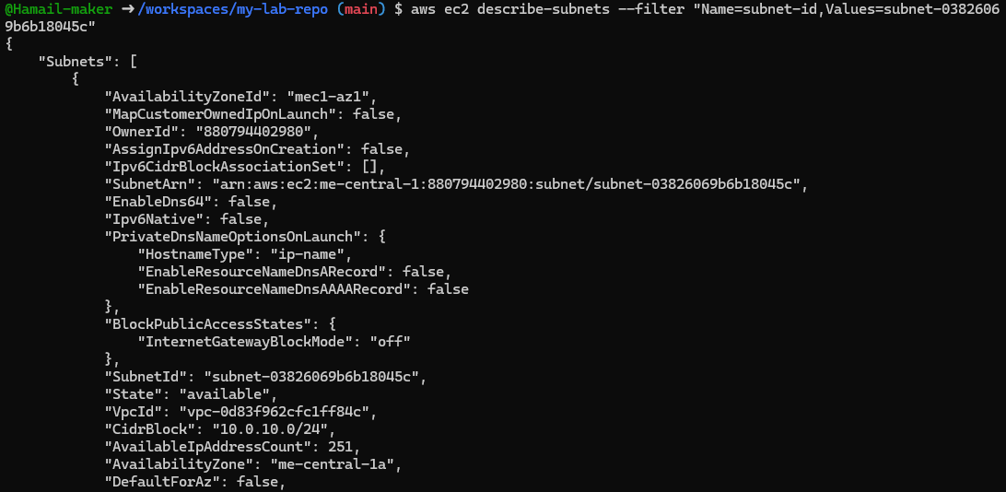
  - Run:
aws ec2 describe-vpcs --filter "Name=vpc-id,Values=<vpc-id>"
    - Save screenshot as: task3_aws_cli_verify_vpc.png — output of describe-vpcs command.

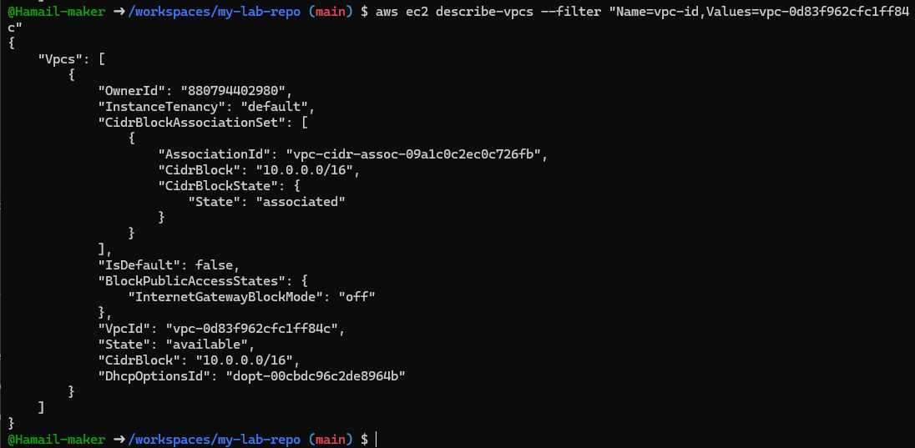
Task 4 — Data Source, Targeted Destroy, Tags
A. Data Source & Resource Creation
- Add to main.tf:
- data "aws_vpc" "existing_vpc" {
- default = true
- }

- resource "aws_subnet" "dev_subnet_1_existing" {
- vpc_id = data.aws_vpc.existing_vpc.id
- cidr_block = "172.31.48.0/24"
- availability_zone = "me-central-1a"
}
  - Use vim to edit and insert code.
  - Save screenshot as: task4_main_tf_datasource_resource_add.png — main.tf with datasource and resource added.
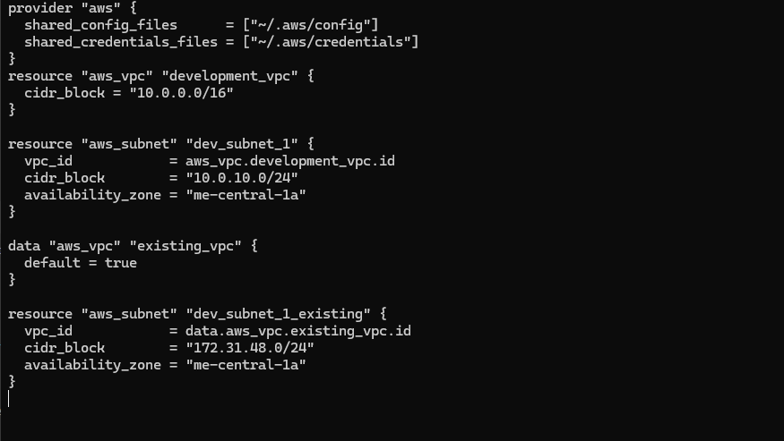
- Apply configuration:
terraform apply
  - Confirm only the new subnet is created.
  - Save screenshot as: task4_terraform_apply_datasource_resource.png — terraform output of resource creation.
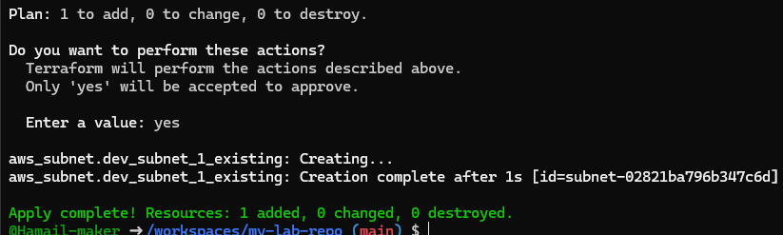
B. Targeted Destroy & Refresh
- Destroy only one resource:
terraform destroy -target=aws_subnet.dev_subnet_1_existing
  - Save screenshot as: task4_terraform_destroy_targeted.png — targeted destroy output.

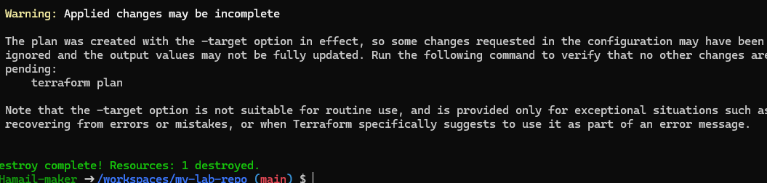
- Refresh state:
terraform refresh
  - Save screenshot as: task4_terraform_refresh_state.png — terraform refresh output.
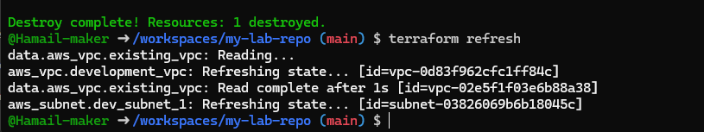
- Re-apply configuration:
terraform apply
  - Save screenshot as: task4_terraform_apply_after_refresh.png — terraform apply after refresh.
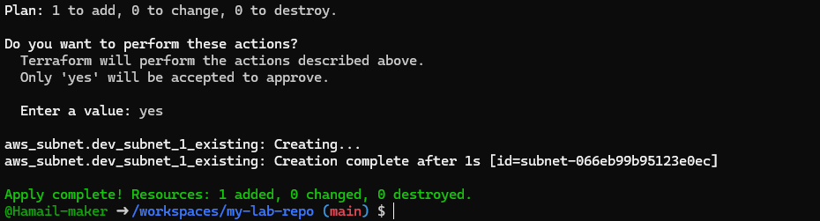
- Destroy all resources:
terraform destroy
  - Save screenshot as: task4_terraform_destroy_all.png — full destroy output.
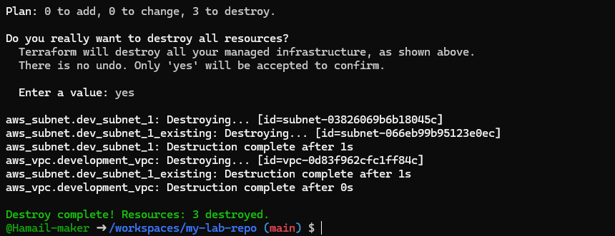
- Plan configuration:
terraform plan
  - Save screenshot as: task4_terraform_plan_output.png — terraform plan showing next changes.
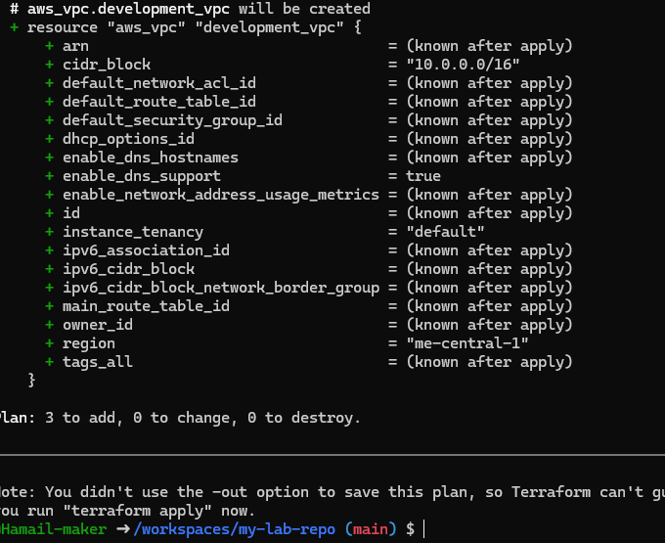
- Apply again:
terraform apply
  - Save screenshot as: task4_terraform_apply_after_destroy.png — output showing resources recreated.
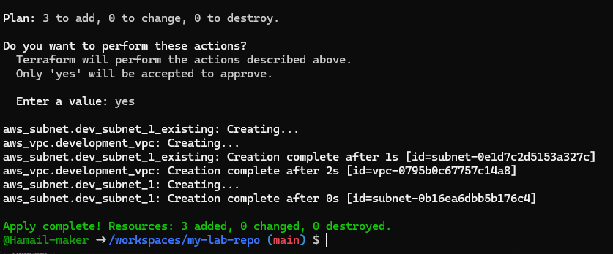
C. Tagging Resources
- Modify main.tf to add tags:
- resource "aws_vpc" "development_vpc" {
- cidr_block = "10.0.0.0/16"
- tags = {
- Name: "development"
- vpc_env = "dev"
- }
- }

- resource "aws_subnet" "dev_subnet_1" {
- vpc_id = aws_vpc.development_vpc.id
- cidr_block = "10.0.10.0/24"
- availability_zone = "me-central-1a"
- tags = {
- Name: "subnet-1-dev"
- }
- }

- resource "aws_subnet" "dev_subnet_1_existing" {
- vpc_id = data.aws_vpc.existing_vpc.id
- cidr_block = "172.31.48.0/24"
- availability_zone = "me-central-1a"
- tags = {
- Name: "subnet-1-default"
- }
}
  - Use vim to update tags.
  - Save screenshot as: task4_main_tf_tagging.png — main.tf with tags added.
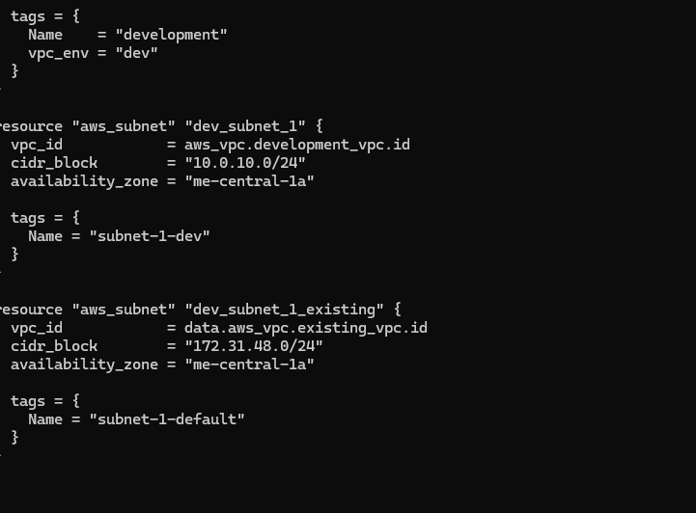
- Run:
- terraform refresh
terraform apply -auto-approve
  - Save screenshot as: task4_terraform_apply_tagging.png — output showing tags applied.
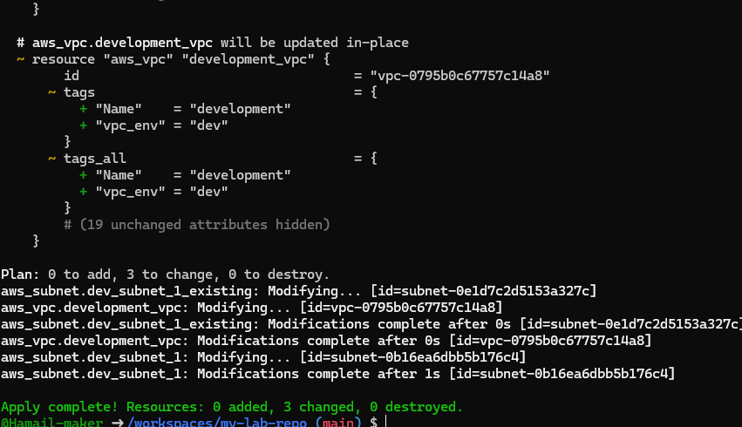
- Remove vpc_env = "dev" tag from development_vpc resource, re-plan/apply:
  - Save screenshot as: task4_terraform_plan_remove_tag.png — plan output showing tag removal.
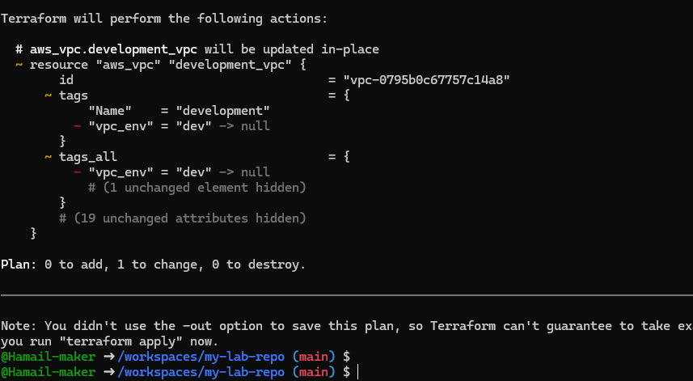
  - Save screenshot as: task4_terraform_apply_remove_tag.png — apply output showing tag deleted.

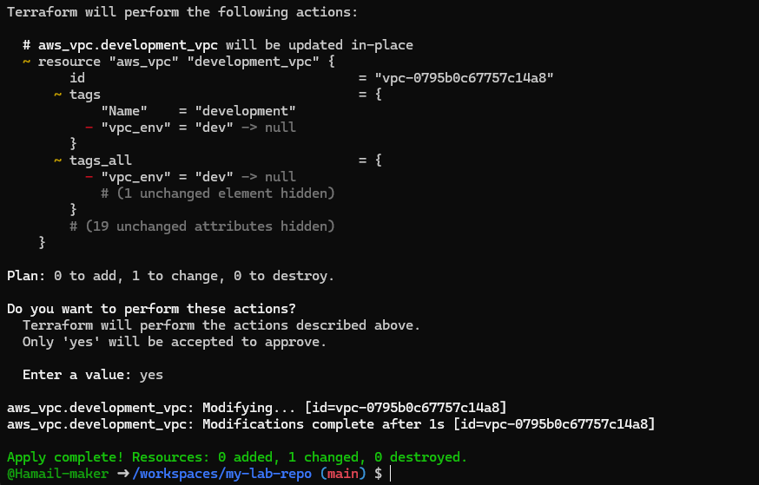
Task 5 — State File Inspection & Terraform State Commands
- Destroy all resources:
terraform destroy
  - Save screenshot as: task5_terraform_destroy.png — destroy output.
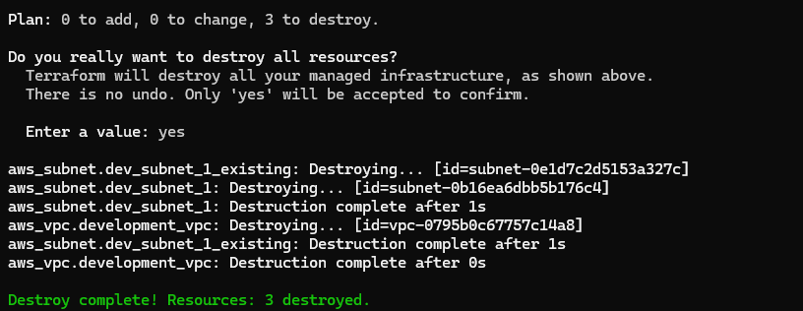
- Inspect state files after destroy:
  - Run:
cat terraform.tfstate
    - Save screenshot as: task5_terraform_state_file_empty.png — output showing terraform.tfstate is empty after destroy.
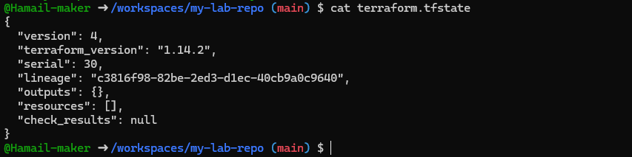
  - Run:
cat terraform.tfstate.backup
    - Save screenshot as: task5_terraform_state_backup_prev.png — output showing backup file with previous resources.
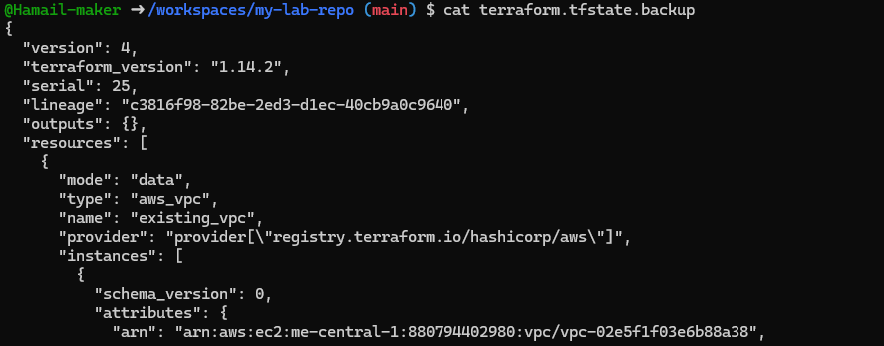
- Recreate resources:
terraform apply
  - Save screenshot as: task5_terraform_apply_recreated.png — apply output, resources recreated.
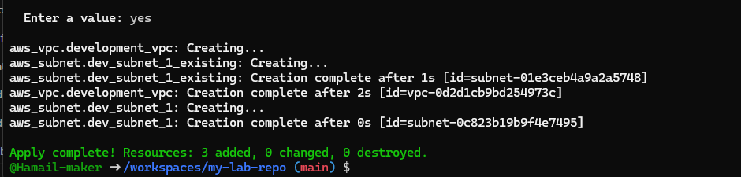
- View state files:
  - Run:
cat terraform.tfstate
    - Save screenshot as: task5_terraform_state_file_populated.png — output showing populated terraform.tfstate after restore.
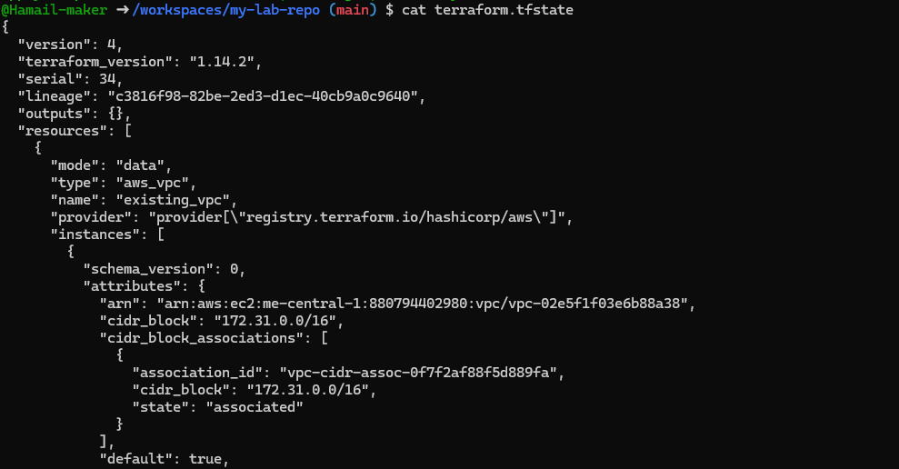
  - Run:
cat terraform.tfstate.backup
    - Save screenshot as: task5_terraform_state_backup_empty.png — output showing backup file empty after restore.
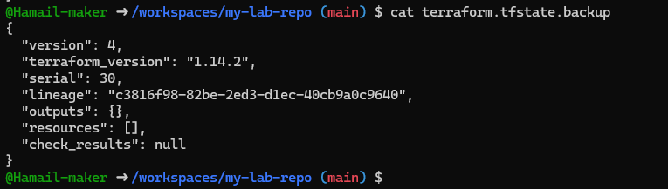
- List resources:
terraform state list
  - Save screenshot as: task5_terraform_state_list.png — terraform state list output.
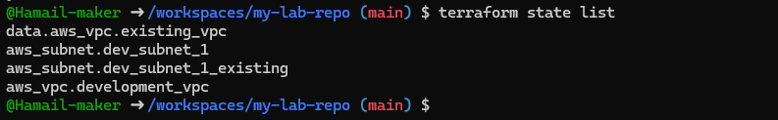
- Show full attributes:
terraform state show <resource-name>
  - Save screenshot as: task5_terraform_state_show_resource.png — state show output for one resource.
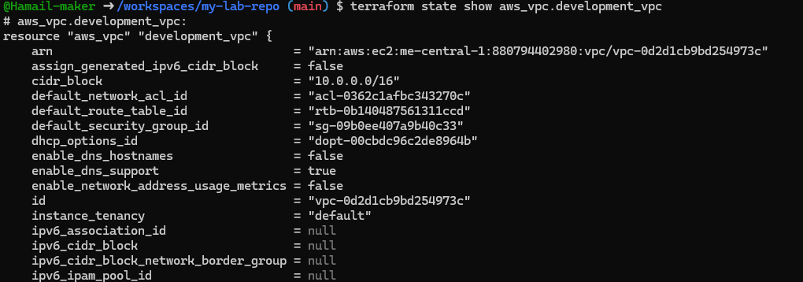
- Note: Do NOT run the following (for information only):
- terraform state rm <resource-name>
  - Mentioned for knowledge — do not run.
Task 6 — Terraform Outputs & Attributes Reporting
- Add outputs in main.tf:
- output "dev-vpc-id" {
- value = aws_vpc.development_vpc.id
- }
- output "dev-subnet-id" {
- value = aws_subnet.dev_subnet_1.id
- }
- output "dev-vpc-arn" {
- value = aws_vpc.development_vpc.arn
- }
- output "dev-subnet-arn" {
- value = aws_subnet.dev_subnet_1.arn
}
  - Save screenshot as: task6_terraform_outputs_basic.png — output values for ids and arns after apply.
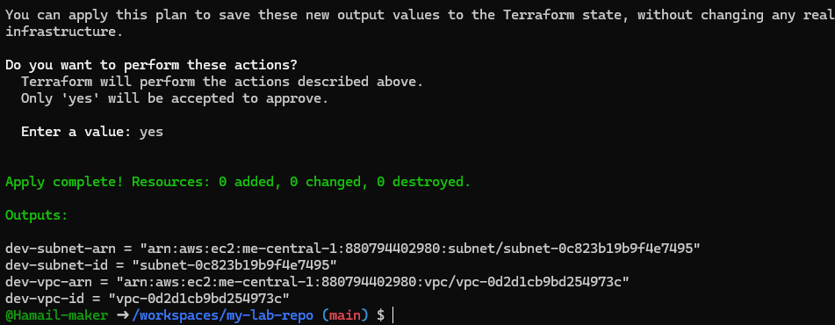
Return ALL of the following output attributes from your VPC and Subnet resources:
- a) cidr_block
- b) region
- c) tags.Name
- d) tags_all
Expand output section in main.tf accordingly:
output "dev-vpc-cidr_block" {
value = aws_vpc.development_vpc.cidr_block
}
output "dev-vpc-region" {
value = aws_vpc.development_vpc.region
}
output "dev-vpc-tags_name" {
value = aws_vpc.development_vpc.tags["Name"]
}
output "dev-vpc-tags_all" {
value = aws_vpc.development_vpc.tags_all
}
output "dev-subnet-cidr_block" {
value = aws_subnet.dev_subnet_1.cidr_block
}
output "dev-subnet-region" {
value = aws_subnet.dev_subnet_1.availability_zone
}
output "dev-subnet-tags_name" {
value = aws_subnet.dev_subnet_1.tags["Name"]
}
output "dev-subnet-tags_all" {
value = aws_subnet.dev_subnet_1.tags_all
}
Run terraform apply and record outputs.
- Save screenshot as: task6_expanded_outputs.png — output values for each required attribute after apply.
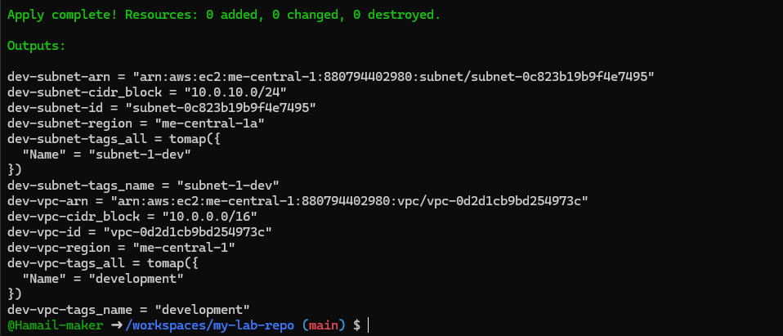
Cleanup — Delete Resources & State Verification
- Destroy all resources:
terraform destroy
  - Save screenshot as: cleanup_destroy_resources.png — destroy output.
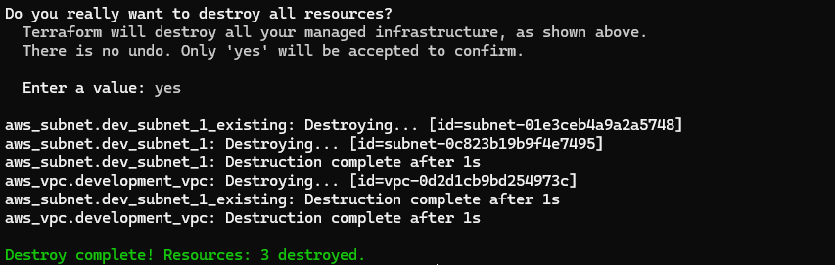
- Inspect state files:
- cat terraform.tfstate
cat terraform.tfstate.backup
  - Save screenshot as: cleanup_state_files.png — outputs showing file contents after clean-up.
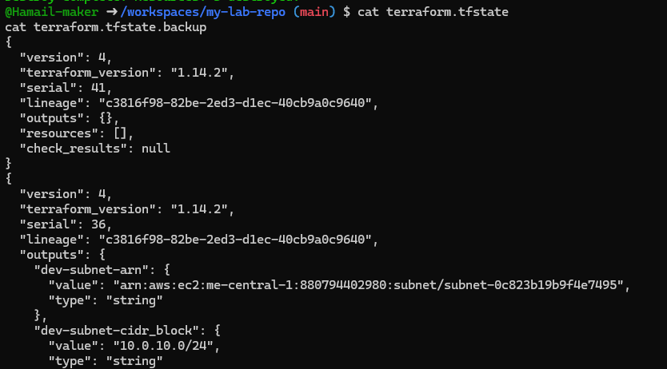
- Reapply then compare state and backup files to see differences.
